NINGBO EVERLIFT MACHINERY CO., LTD.



Note: Please read this manual before using!
Note: Please do not use it before completing the installation!

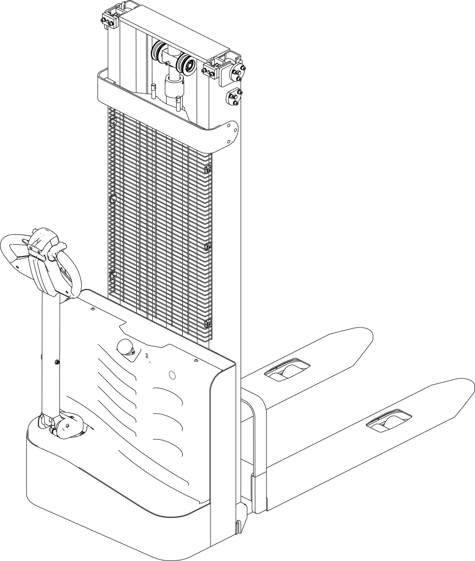
The Specification of ELES-15J

CL Economical Type Full Electric Stacker
Add: #66 Dasong Road Zhanqi Town Yinzhou District Ningbo City China 315144
JANUARY.2022

Catalogue

1. The Introduction 3
1.1.Overview 3
1.2.Parameter 3
2. Basic structure and working principle 5
2.1 Basic structure 5
2.2. Working principle 6
2.3.Electrical principle 8
2.4. Hydraulic Principle 10
3.Safety operation and attention 11
3.1 General regulation 11
3.2 Transportation and storage 11
3.3 Check before usage 11
3.4 Operation regulation 12
4.Maintenance 16
4.1 Maintenance procedures 16
4.2 Daily Maintenance 17
4.3 Maintenance Manual 17
4.4 Maintenance, Recharging and Replacement of the Accumulator(Battery) 19
5.Repair Manual 23
5.2 Preparation before repair 24
5.3 Check hydraulic oil mass 24
5.4 Complete repair,the preparation before using 24

1. The Introduction

1.1.Overview
This manual include all information about CL Economical Type Full Electric Stacker (as follow ‘stacker’ ).
The model of stacker ‘CL15GB—15 rated load 1.5ton’ is in accordance with the documents of JB/T8452-1996, ‘GB’ is the model code.
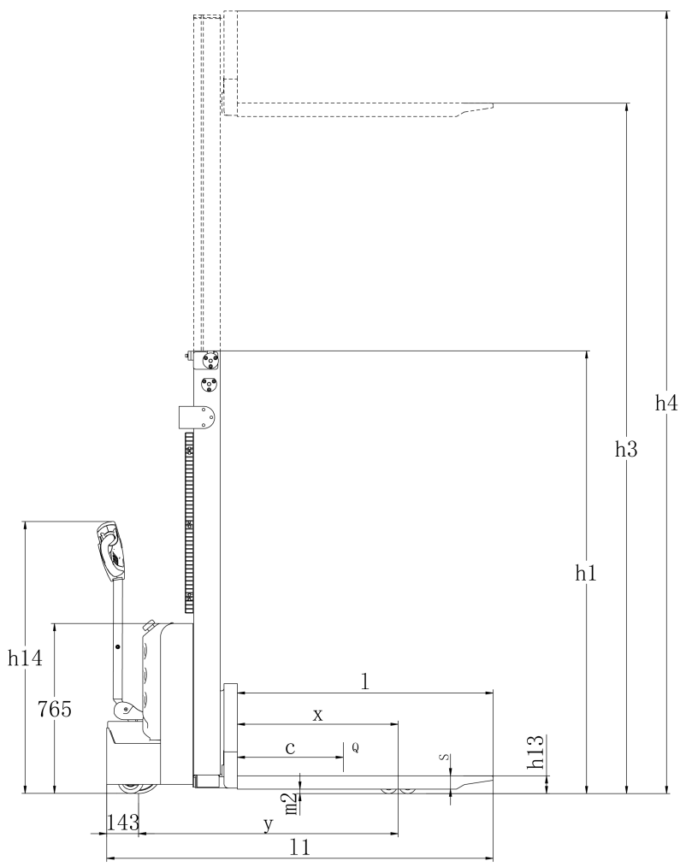

1.2.Parameter

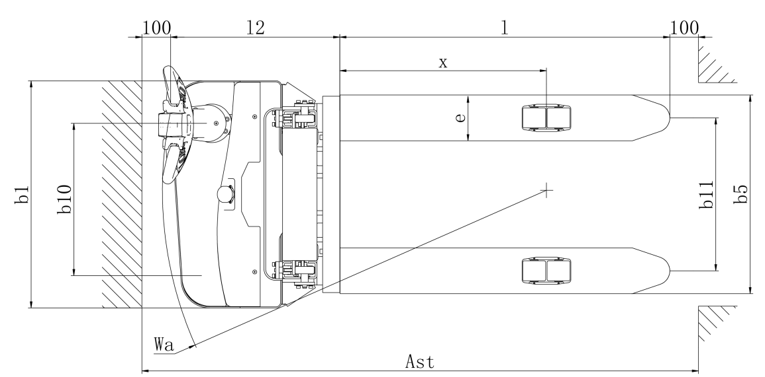

Model |  | CL15JB
Load capacity | Kg | 1500
Load capacity on Max. Height | Kg | 1000
The max. lifting height | mm | 3000
Load center distance | mm | 600
Fork length | mm | 1150
Single fork width | mm | 160
Two fork outside width | mm | 570/695
Lowerest fork height | mm | 86
Length of fixed leg | mm | 928
Width of single fixed leg(including front wheel frame) | mm | 124
Inner width of two fixed leg | mm | 262/387
Outer width of two fixed leg | mm | 534/659
Aisle width for pallets 1000×1200 crossways | mm | 2074
Aisle width for pallets 800×1200 lengthways | mm | 2040
Turning radius | mm | 1342
Front wheel size, number |  | φ80×70、4
Rear wheel size,number |  | φ210×70、1
Balance wheel size,number |  | φ115×55、1
Total length | mm | 1740
Total width | mm | 795
Extended mast height | mm | 2060
Lowered mast height | mm | 3424
Battery voltage (dimensions) | mm | 2×12V/100AH（260/169/215）
The controller |  | 24V/90A
The charger |  | 24V/10A
Lifting Motor |  | 2.2kw. Lift speed：laden/unladen：92/136mm/s；decline speed：laden/unladen：112/98mm/s
Driving Motor |  | 0.75kg. Driving speed：laden/unladen 4/4.2km/h
Weight | Kg | 465/495

2. Basic structure and working principle

2.1 Basic structure
Stacker use battery as power source, with electrical and hydraulic operation to control the height of lifting, and walk function. Basic structure as follow.
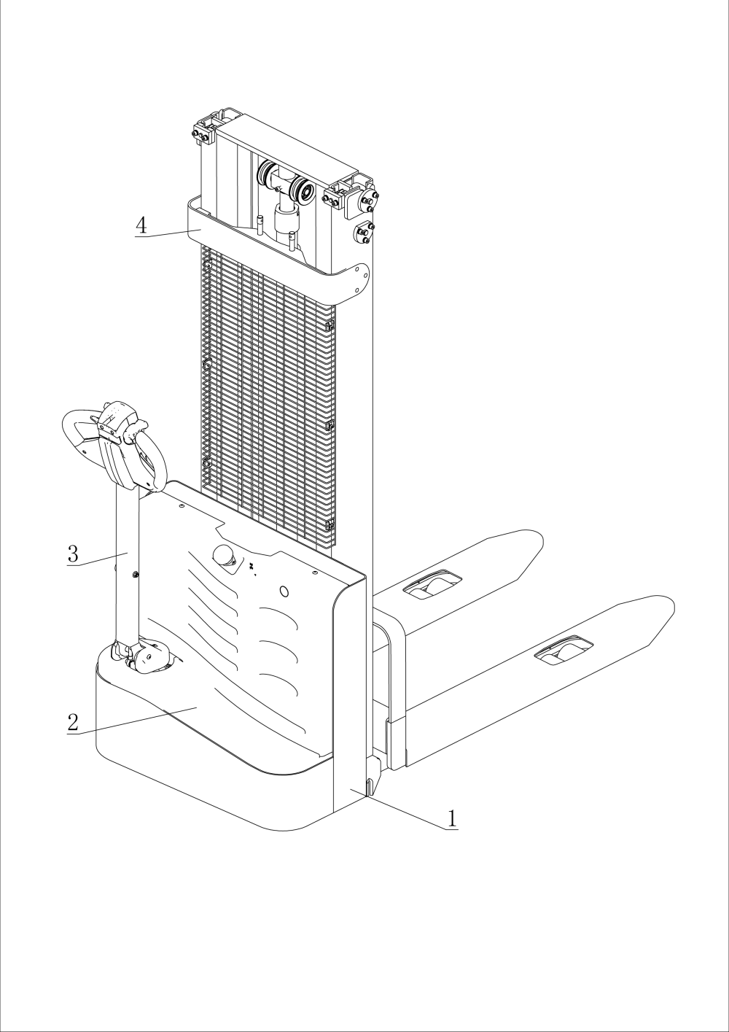
1.Body Assembly 2.Cover 3.Handle parts 4.Mast Assembly

2.2. Working principle
2.2.1.Walking system
Stacker use battery as the power source through controlling DC motor on the driving wheel to fulfill the function of walking, DC motor convert the high speed low torque to low speed high torque through gearbox, being implemented by driving wheel. The speed of walking is controlled by accelerator .
In general, every 100 hours change the lubricating oil in the gearbox.
During usage,if any noise coming from gearbox, please stop the stacker and check, to judge whether bearing or gear have some problem.

2.2.2.Steering system
Stacker’s steering is controlled by the operation handle, handle shaft and driving motor.

2.2.3.Operation system
1.Ascending/descending button
2.Travel switches
3.Belly switches(a kind of safety switch during operation)
4.Horn button
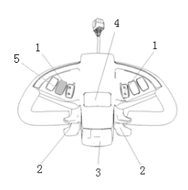
5.Electricity meter

2.2.4. Braking system
Braking performance depend on road condition and vehicle loading condition
Braking function can be activated by as follow method：
The travel switch (2) moved back to '0' position or release this switch, the vehicle braking is activated. Vehicle brake to stop
Through the travel switch (2) driving direction move directly to the opposite direction from a vehicle with regenerative braking, until it began running in the opposite direction.
If the handle is moved upwards or downwards to the braking zone ('B'), vehicle braking activate. If release handle shaft, the shaft will automatically move to the handle braking area ('B'). The vehicle brake activate until the vehicle stop.
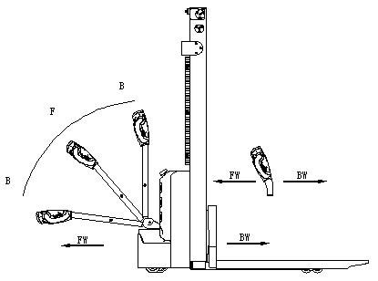
Belly switch (3) can prevent the operator from extrusion. When the vehicle move to (‘FW’) direction and face some obstacle, if you press this switch, the vehicle speed begin to slow and reverse driving direction to ('Bw.'), then stop. If the handle on the operating area and the vehicle is not running, please consider this switch can be acting.

2.2.5 Working system
Stacker’s main working agency is fork, depending on the fork to fulfill the function of load& unload,stack and short distance transport.
Fork is installed in the sliding shelf, the sliding shelf move up and down inside the mast,through chain drive or inner mast movement to fulfill the function of goods lifting or piling up on the goods shelf. The working of chain drive and inner mast movement is functioning in the basis of lifting oil cylinder’s extend-retract function. Stacking process is implemented through the control of oil cylinder extend-retract function.
Cylinder’s extend-retract is controlled by the operation handle, the pumping station provides pressure oil. In the lifting oil cylinder of the loop equipped with safety relief valve, control the speed of slowing down the mast, to achieve the effect of security descending.

2.3.Electrical principle
2.3.1 Electrical system
Stacker electrical system includes walking and operation control, etc.The stacker use communication electronic assembly CURTIS1212S from America.
The instrument have the function of electricity indicator, working time display and voltage protection.When the battery power is too low, electricity meter will cut off the oil pump motor’s start control circuit, the stacker can only walk but not ascend fork, and will indicate need charging immediately.
Oil pump motor is 5 minutes a week of dc motor, so the oil pump motor is not suitable for continuous operation for a long time.Lifting action should have time interval, not continuous, otherwise it will cause motor being overheated, even broken.
Special tips:After a long time using, the oil pump motor starter of the stacker is likely to fail, specific performance is can not absorb or after absorbing can't disconnect.The latter one shown as the oil pump motor keep rotating without pulling the control handle.in this occasion should immediately stop the vehicle, cut off power supply to make the oil pump motor stop running,then change the starter.

Electrical principle chart

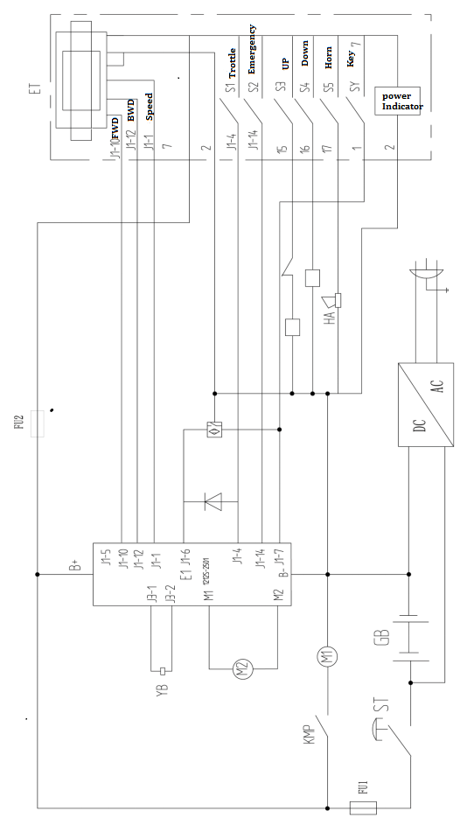

2.4. Hydraulic Principle
The oil pump motor drive gear pump,to provide hydraulic power, lifting cylinder are responsible for lifting the fork. The ascend-descend oil circuit is controlled by the button on the handle. Ascend-descend action is under the control of single-acting oil circuit on the valve block. This model’s hydraulic system pressure are tested in the factory, if you are not our company after-sales person or professional maintenance person, please do not adjust the machine by yourselves, to avoid safety accident.

Hydraulic principle chart
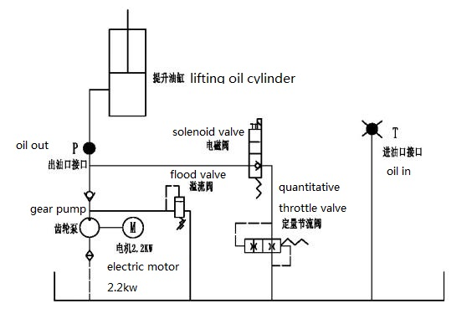

3.Safety operation and attention

3.1 General regulation
3.1.1 Operator need stacker operation qualification(being approved by relevant authorities).
3.1.2 Operator need to read this manual before operation.
3.1.3 Stacker can not carry passengers.
3.1.4 Operator need to pay attention to the operation environment, including people around and other objects.
3.1.5 Without permission from manufacturer, can not change any part of the stacker, to avoid influence its performance.

3.2 Transportation and storage
3.2.1 Use container or truck during load and transport should pay attention to：
1).Front and rear wheels being fixed with wedge, avoid sliding in the process of transportation;
2). Using the lasso, not placed in the weak structure of the stacker;
3). Stacker carry goods, keep the stacker's center of gravity in the intermediate position of the two forks.
3.2.2 Stacker need to be stored at cool, dry and ventilated place,without sun-scorched and rain-drenched, and pay attention to：
1). Close electric lock, cut off the safety switch power, unplug the power plug;
2). front and rear wheels with block to fix.
3). If long time stop using, need to charge the battery every 15 days.

3.3 Check before usage
3.3.1 If a new stacker have any damage during usage，please stop using and contact supplier to do proper treatment.
3.3.2 No need to add lubricating oil and hydraulic oil to a new stacker.
3.3.3 A new stacker have a battery which has been fully charged before leaving the factory. If stacker leave the factory for a long time without charging and using，may cause low battery during usage. Take care of the electricity meter during usage, when the electricity meter display to the last two warning, must charge at once.

3.4 Operation regulation
To be familiar with the function of each switch/button before operation.
3.4.1 Start, run and stop:
1).Insert the key into the key switch, turn to the right,pull the emergency power safety switch up, open the control circuit.
2).Forks rise above ground about 10 cm
3).Open the travel switch slowly,till the requested speed
4).Any fault of the stacker happening during operation, need to cut off the power immediately, and press the red emergency power switch down.
5).Avoid take a sudden turn during driving the stacker.
6).Using stacker Full load climbing a slope, need to know the condition of the slope, and press the travel switch as much as possible to get a maximum gradeability.
7).When stop driving,put the fork in the bottom,press the emergency switch down, and pull out the key.
3.4.2 The usage of emergency safety switch
Press the emergency safety switch down,then the the stacker’s power off. Method to open it:pull the red button up.
Emergency safety switch is made of plastic, too much pressure may damage it.
3.4.3 The usage of horn button.
Press the horn button in the center of handle to notify people around.
3.4.4 Battery capacity indicator
The stacker battery capacity indicator has electricity capacity display function.
3.4.5 Handling stacking operation
1). How to transport the goods pile on weight
Will forklift drive to the front of the items which need to carry slowly , make fork parallel to the ground, lifting the fork to height, it can be inserted into the freight insert goods fork and move forward slowly, when the goods completely inserted into the goods after parking and stepping on the brakes, manipulating ascend handle, the heavy lifting to a certain height, make the door frame lean back, slowly astern, don't touch the adjacent goods, when weight completely left the heap of goods, reduce the goods to the right position, then walking for handling.
2). The weight on the heap of goods
Will weight low, lean back door frame, to storage goods moving close to the pile of deceleration, when determining forklift with pile goods into a linear state, stepping on the brakes slowly adjust the door frame Angle to the vertical state, increase the weight will be slightly more than goods pile height, and then slowly driving forklift driving forward to pile top stop. Heap controls control lever slowly, once handling stacked drags the weight, the goods fork to the hollow position, from the weight of the goods fork, make sure barrier-free backward position, can retreat. After goods fork out weight reduce goods fork, door frame round of the reentry after handling operation.
3.5. Safety operation regulation
3.5.1.Requirement for operator: The forklift must be operated by a trained operator, He can demonstrate the operation of the goods to the users, and can clearly guide the user how to operate the forklift.
3.5.2 Operator’s rights, obligations and responsibilities：Has been trained by the operation of the vehicle, the driver must be clear of his rights and obligations; and he is familiar with the contents of the relevant operating instructions. If the vehicle is pedestrian type, the driver must also wear safety boots.
3.5.3 Prohibit unauthorized person to operate：The operator is responsible for the vehicle,he need to prohibit unauthorized person to operate. Transport or lift person is also forbidden.
3.5.4 Malfunctions and defects：If the vehicle has any malfunctions or defects,need to inform administrator, If the vehicle cannot be safely operated (e.g.: wheel wear or brake failure), then it must stop using until it is fully repaired.
3.5.5 Safe operation and environmental protection：inspection and maintenance must be performed in accordance with the time intervals on the maintenance list.
Parts of the vehicle cannot be changed without any permission, especially safety devices. The operating speed of the vehicle is not allowed to change.
All original spare parts have been verified by quality assurance department. To ensure the safety and reliability of the operation of the vehicle must use only the manufacturer's spare parts. The old parts, such as oils and fuels must be handled in accordance with the relevant environmental protection rules.
3.5.6 Hazardous area: Hazardous area usually refers to the following range: vehicle or its load lifting devices (e.g. fork or accessories) is dangerous for personnel when running or lifting movements, or the ongoing regional transport loads. Typically, this range extends to the load or vehicle accessories landing area.
Unauthorized personnel must be asked to leave the dangerous zone. As long as the situation might cause some kind of damage, the driver must give a warning, if the driver asked the person to leave but did not leave the hazardous zone, the driver must immediately stop the vehicle.
3.5.7 High-risk environment：Working in high-risk environment, operator must have a special design to be protected
The vehicle was not specially designed for the high-risk environment.
3.5.8 Safety devices and warning signs: Safety devices, warning signs and warning notes described in the previous operating instructions must be taken seriously enough.
3.5.9 Driving in public places: the vehicle is forbidden to drive in public places other than special areas.
3.5.10 Distance between vehicles: keep an appropriate distance, avoid the front vehicle suddenly stop.
3.5.11 headroom: When the headroom is below the cargo or mast, it is forbidden to use the vehicle.
3.5.12 Using in the elevator and loading platform maneuvering: if there is sufficient loading capacity, won’t affect the operation of the vehicle, and being agreed by the operator of the vehicle, then the elevator and loading platform can be used for vehicle transport. Before entering the elevator or loading station, operator must personally identify. The goods must be placed in front and occupy an appropriate place, to avoid touching the wall of the elevate when the vehicle enters the elevator. When personnel and vehicles take the elevator together, person can enter only after the vehicle has safely entered, and person must leave before the vehicle.
3.5.13. Driving aisle and working area: The vehicle must be operated on the specified aisle, all non-related person must leave the work area, and cargo should be stacked in designated places.
3.5.14 Operation Management：Driving speed must be adapted to local conditions. When through the corners, narrow passage, swing doors and closed place, speed must be slowed down. Drivers must be able to visually an adequate braking distance between vehicle and the front vehicle, and he must remain in control of his vehicle. Sudden stop (unless urgent needs), rapid U-turn, chased each other in the Aisle is not allowed.
3.5.15 Visibility: The driver must look attentively at the direction of driving, to ensure the front situation is clearly visible. When the vehicle is backing off, if the carriage of goods block the line of sight, a second person walk in front of the vehicle to give appropriate guidance and warnings is necessary.
3.5.16 Pass through the ramp: Only a known ramp which should be clean, non-slip, and with the vehicle technical availability was allowed to go through. The goods on the forks must face uphill. It is forbidden to turn back, move diagonally or park on the ramp. The operator must slow down when going through the ramp, and prepare to brake at any time.
3.5.17 Load capability on ground: when the vehicle is in operation, make sure the load pressure of the body weight or wheels on the ground does not exceed the load capacity of the ground .
3.5.18 Vehicle Change: Any possible changes or modifications for rated load, stability or safe operation of the vehicle, must obtain prior written approval from origin manufacturers or its successor. After vehicle manufacturer check and approve the changes, nameplates, labels and markings of Operation and Maintenance Manual must be modified as well.

4.Maintenance

4.1 Maintenance procedures
Maintenance technician: The maintenance and service should only be performed by special personnel trained by the manufacturer. After the technician sent by after-sales department of the manufacturer completed maintenance and servicing work, they should sign on the service log.
Cleaning Operation: Flammable liquid can not be used for cleaning the stacker. Before cleaning, take safety precautions to prevent electric sparks (e.g. sparks caused by short circuit). When operating the accumulator, connectors on it must be disconnected. Use soft air suction or compressed air, non-conductive and anti-static brushes to clean electric and electronic components.
Operation of Electric System: Operation on the electric system should only be performed by specially trained personnel. Before performing any operation on the electric system, precautions must be made to prevent electric shock. When operating the accumulator, connectors on it must be disconnected.
Installation: When repairing or replacing hydraulic components, electric and electronic components, make sure to install them back to their original positions.
Wheels:Quality of the wheels has significant effect on stability and driving performance of the stacker. Modification on wheels can be performed only with the approval from the manufacturer. When replacing wheels, ensure that the stacker is levelled as delivery state(wheels must be replaced in pairs, i.e. replace right wheel together with left one).
Lifting chain and rollers: Chain and rollers will be worn quickly without good lubrication.Perform periodic lubrication according to following maintenance table. Shorten the lubrication period under adverse operation conditions (such as in dusty and hot environment).
Hydraulic oil pipe: The oil pipe must be changed every 6 years. When change the hydraulic assembled parts, the oil pipe should be also changed.

4.2 Daily Maintenance
4.2.1 Check every pole, every cable and their covers.
4.2.2 Check if the accumulator box is secured.
4.2.3 Check the stacker for oil leakage.
4.2.4 Check the chain, rollers, fork, oil pipes and horn.
4.2.5 Check the brake.
4.2.6 Check the wear and tear of drive wheels and loading wheels.

4.3 Maintenance Manual
It is very important for safe operation of the stacker to perform overall professional maintenance. Failure in performing maintenance according to specified interval may cause malfunction of the stacker, and potential risk to human and equipment.
Maintenance periods listed in this manual apply to single shift a day under normal operation conditions. If using in dusty environment, the ambient temperature varies remarkably or in multi-shift situation, the maintenance period has to be shortened.
Maintain the stacker according to following maintenance list. Maintenance periods are as follows:
W1 = Every 50 work hours, but at least once a week.
M3 = Every 500 work hours, but at least once every three months
M6 = Every 1000 work hours, but at least once every six months
M12 = Every 2000 work hours, but at least once every 12 months

Additional operations should be performed in trial run period:
(In initial 50 – 100 working hours or after two months)
— Check the nuts on the wheels, and tighten them if necessary.
— Check the hydraulic components for leakage, and tighten them if necessary.
—Replace the hydraulic filter.

List of maintenance
 |  |  |  | W | A | B | C
Braking | 1.1 | Check the air gap of electromagnetic brake |  |  |  | ●
Electric System | 2.1 | Check switch operation, display the function of the equipment and components |  | ●
Electric System | 2.2 | Check the alarm system and safety device |  |  | ●
Electric System | 2.3 | Check whether there is any damage on the cable and terminal is rigid |  |  |  | ●
Electric System | 2.4 | Check the function of the micro switch Settings |  | ●
Electric System | 2.5 | Check the controller |  |  |  | ●
Electric System | 2.6 | Fixed cable and motor |  |  |  | ●
Energy Supply | 3.1 | By observing the battery |  |  | ●
Energy Supply | 3.2 | Visual inspection battery charging plugs |  |  |  | ●
Energy Supply | 3.3 | Check whether the battery cable connection fastening, if necessary, with oil daub electrode |  |  |  | ●
Traveling System | 4.1 | Check if have gearbox abnormal sound |  |  |  | ●
Traveling System | 4.2 | Check the travel agency, and the oil, check the reset function of operating handles |  |  | ●
Traveling System | 4.3 | Check the drive wheels and bearing wheel for wear and damage |  |  |  | ●
Traveling System | 4.4 | Check the wheel bearing and fixed |  |  |  | ●
Massive Structure | 5.1 | Check whether the framework has damaged |  |  |  | ●
Massive Structure | 5.2 | Check whether the sign is complete |  |  |  | ●
The hydraulic system | 6.1 | Check the function of the hydraulic system |  |  | ●
The hydraulic system | 6.2 | Check the hoses, pipes and interface whether fastening, sealing and presence of damage |  |  | ●
The hydraulic system | 6.3 | Check whether the damaged piston and cylinder sealed and fixed |  |  |  | ●
The hydraulic system | 6.4 | Check the load chain Settings. |  |  |  | ●
The hydraulic system | 6.5 | Visual inspection door frame and check on the surface of the roller of roller wear |  |  |  | ●
The hydraulic system | 6.6 | Check the goods fork teeth and load parts for wear and damage |  |  |  | ●
The hydraulic system | 6.7 | Check the tank oil level |  |  |  | ●
The hydraulic system | 6.8 | Update the hydraulic oil |  |  |  |  | ●

4.4 Maintenance, Recharging and Replacement of the Accumulator(Battery)
The stacker must be parked in a safe location before any operation on the accumulator.
4.4.1 Maintenance Technician
Only qualified technician can perform operations on the accumulator such as recharging,maintenance and replacing. Before operation carefully read instruction manuals including operation manual, replenishment preparation and recharging requirements.
4.4.2 Fire Prevention Measures
Never smoke or use open fire when perform operations on the accumulator. The accumulator should be away from flammable material at least two meters when storage or recharging. The location for accumulator storage should be well ventilated and equipped with fire fighting devices.
4.4.3Maintenance of the Accumulator
1) Keep the nuts on every battery cell dry and clean. Tighten every terminal and cable end,and brush them with grease to prevent corrosion. Naked cable ends and terminal posts should be covered with a skid-proof insulating cover.
2) Every two cells should be well-connected. Check the nuts on each pole, if loose, tighten the nuts.
3) Keep the surfaces of accumulator clean and dry. After the completion of recharging,clean spilled acid with cotton yarns or brush. And clean with wet towel if necessary.
4) Over recharging and over discharging should be avoided, and fast charging and insufficient recharging are also not allowed. Otherwise life span of the accumulator may be affected.
5) Do not put conductive objects including metal tools on the accumulator, or short circuit or even explosion may be caused.
6) Never spill any hazardous liquid or solid material on surfaces of the accumulator. When using a densimeter or a thermometer, make sure the surface is clean and clear.
7) Recharge the discharged accumulator in time. Delayed recharging may damage the accumulator. Do not delay recharging more than 24 hours.Recharging of the accumulator may not work outdoors in cold weather. In this case, move it indoors to perform recharging.
8) If the accumulator will not be in use for a long time, it should be recharged and discharged once every month and it should be fully recharged every time.
9) During recharging or using, the liquid level of electrolyte lowers because of water evaporation, so pure water should be added.
10) If individual cell fails, identify the cause and repair the cell immediately. Replace the cell when it cannot be repaired.
11) The site for recharging should be well ventilated. It is prohibited to smoke or use open fire, avoiding the risk of hydrogen explosion.
12) The electrolyte in accumulator is toxic and corrosive. For this reason, always wear working suit and protection glasses to protect your body from contacting the electrolyte in accumulator.
13) If your clothes, skin or eyes are spilled with acid liquid in accumulator, flush with large amount of clean water. For skin and eyes, flush with large amount of clean water and also seek doctor’s treatment immediately. Acid spillage must be neutralized and treated immediately.
14) The weight and dimensions of the accumulator have remarkable effect on stability of the stacker. Therefore do not modify the type of accumulator without approval from the manufacturer.
15) Never discharge in large current, for example, performs travelling and lifting simultaneously.
4.4.4 Dispose worn-out accumulators
Worn-out accumulators should be recycled according to local regulations, and stored in specified zone or cast-off treatment zone. These works should be done by qualified specialized companies.

4.4.5 Specification of the accumulator
Battery |  | Charger
Rated power：24V | Rated capacity：100Ah | Input：195/265VAC  50/60Hz | Output：DC24V10A
Uninsulated terminal poles on the accumulator should be protected with an insulated cover. When connecting the accumulator and socket, make sure to stop the stacker and put the switch at position “0”.When replace or install the accumulator, make sure the accumulator is fixed securely in battery box.

4.4.6 Storage, transportation and installation of the accumulator
The stacker must be parked on the level ground steadily. To prevent short circuit,naked cable ends and the terminal posts should be covered with insulated covers. When pulling out the accumulator, properly arrange removed accumulator's connectors and cables without blocking access of the accumulator.
4.4.7 Battery power indicator
Battery power display table:ten article showing represent 100% of the battery.
With the consumption of battery capacity, the glowing article shows will be from top to down.
The color of LED show the different states ：
Name | LED Color
The standard battery remaining power | Green | 70-100%
The standard battery remaining power | Orange | 30-60%
The standard battery remaining power | Red blinking | 0-20%

Battery discharge on 70%,red lamp will blinking“Energy storage”.
Battery discharge on 80%,two lamp will blinking“run out of battery”,Need to charge the accumulator.
4.4.8 Charging
The Electric stacker is supplied with a special charger for recharging.
Read the instruction manual carefully before recharging.
The batteries should be recharged in well-ventilated areas. Make sure no metal objects placed on the accumulator. Check all cables connection and connectors for obvious defects. Observe strictly all safety instructions, e.g. replenishment of the accumulator and preparation for recharging.
For safety working, the stacker should be added protective cover before using.

4.4.9 Disassemble and install accumulator
Cut off the power,stop the stacker,before disassemble and install accumulator
Disassembling and Installing step of accumulator as follow
A: Unscrew two fixed screw and take down the cover(1)
B: Unscrew two fixed screw and take down battery limiting plate(2)
C: Unscrew two fixed screw and remove two battery cable(3)
D: Place or change the accumulator according to the direction of graphic(4)
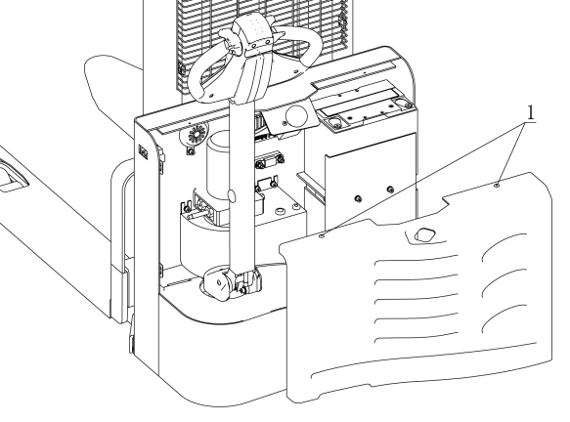
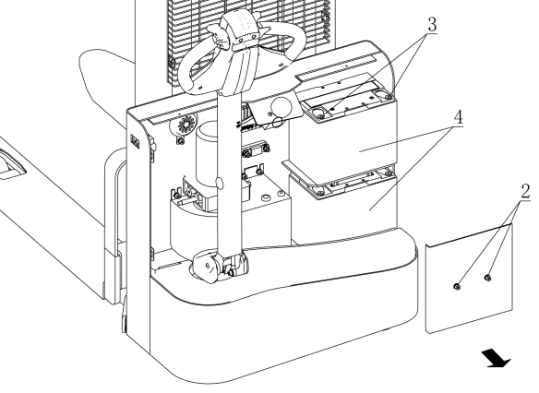
Installing the accumulator, in the opposite order, pay attention to the battery load position and the wiring to confirm they are correct. Take care of the battery cable, to avoid cutting.

5.Repair Manual
5.1 Malfunction analysis
Malfunction | Cause | Treatment
The vehicle can't move | The battery connector is not connected | Check the battery connector，connected if necessary
The vehicle can't move | Electric lock switch on “OFF” position | Electric lock switch turn to “0”position
The vehicle can't move | Emergency Stop Switch not open | Open the Emergency stop switch
The vehicle can't move | Battery power runs out | Check the battery charge，If it is necessary to recharge
The vehicle can't move | The stacker being charge | Interrupt charging process
The vehicle can't move | The fuse is damaged | Check the fuse
The goods cannot ascend | The stacker no running | According to the "vehicle can not move" listed in the fault processing method of operation
The goods cannot ascend | Less hydraulic oil | Check the hydraulic oil
The goods cannot ascend | The fuse is damaged | Check the fuse
The goods cannot ascend | Over weight | Note the load capacity
The goods cannot ascend | the micro switch of lifting contact is not good or damaged | Check the fuse
The goods can't drop | The dirty oil blocking control valve | Check the hydraulic oil and cleaning control valve, and if necessary change, the hydraulic oil.
The goods can't drop | Lowering solenoid valve no open or damaged | Check the lowering solenoid valve or change
Can't stop rising | Lifting micro switch damaged | Cut the power，change lifting micro switch
A direction moving | Micro switch and cable jumper contact is not good | Check the micro switch and connect jumper witch on the control handle
The stacker move slowing | Battery power shortage or homologous cable jumper contact is not good | Check the battery power led and homologous cable jumper contact.
The car suddenly started | Controller is damaged. | Change the controller
The car suddenly started | The handle which control the forward or back is no reset. | Repair or change
If above steps still can not solve problems, please contact after-sales service department of the manufacturer and have the problems solved by specially trained technicians.

5.2 Preparation before repair
To prevent possible accidents during maintenance and repair work, following preparations must be done:
— Park the stacker safely.
— Press the emergency stop switch and disconnect the connectors on accumulator.

5.3 Check hydraulic oil mass
— Get the stacker ready for maintenance or repairing.
— Open the cover of electric unit.
— Check hydraulic oil level in oil tank.
Check the hydraulic oil level only after the fork and main frame are lowered to their lowest position.

5.4 Complete repair,the preparation before using
Use the stacker only after following operations have been completed.
— Clean the stacker.
— Check the brake.
— Check the emergency stop switch.
— Check the horn.

This manual final interpretation retained by manufacturers.

